Ant (Java)
# Source: AI Source: Provided by: [Data Path: Persons Table -> ID Column: 1, Name_En Column: Motasem Essam] -> From: [ChatGPT] on [1/26/2026]
Apache Ant is a Java-based build automation tool used to compile, package, and manage Java projects using XML configuration files.
👉 Think of it like Make for Java, but using XML instead of scripts.

⚙️ What Ant Does:
# Source: AI Source: Provided by: [Data Path: Persons Table -> ID Column: 1, Name_En Column: Motasem Essam] -> From: [ChatGPT] on [1/26/2026]
● Compiles Java source files
● Packages applications into JAR/WAR files
● Automates build processes
● Runs tests and deployment tasks
● Uses XML-based configuration (build.xml)

✅ Why Use Ant?
# Source: AI Source: Provided by: [Data Path: Persons Table -> ID Column: 1, Name_En Column: Motasem Essam] -> From: [ChatGPT] on [1/26/2026]
Feature Description
📄 XML-Based Uses structured XML instead of scripts
⚙️ Flexible Supports custom build processes
🔁 Automation Automates compile, test, and deploy
📦 Packaging Creates JAR, WAR, EAR files
💻 Cross-Platform Works anywhere Java runs

📦 Example build.xml
# Source: AI Source: Provided by: [Data Path: Persons Table -> ID Column: 1, Name_En Column: Motasem Essam] -> From: [ChatGPT] on [1/26/2026]
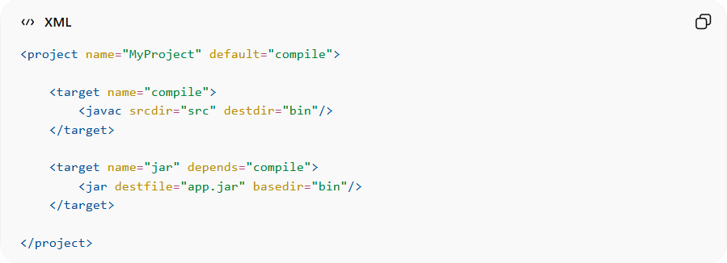
<project name="MyProject" default="compile">

<target name="compile">
<javac srcdir="src" destdir="bin"/>
</target>

<target name="jar" depends="compile">
<jar destfile="app.jar" basedir="bin"/>
</target>

</project>

▶️ Common Ant Commands
# Source: AI Source: Provided by: [Data Path: Persons Table -> ID Column: 1, Name_En Column: Motasem Essam] -> From: [ChatGPT] on [1/26/2026]
▶️ Run default target:
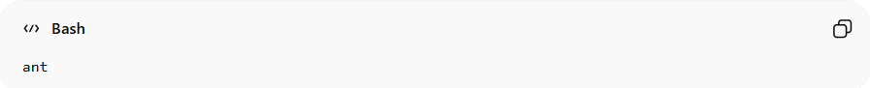
ant
🎯 Run specific target:
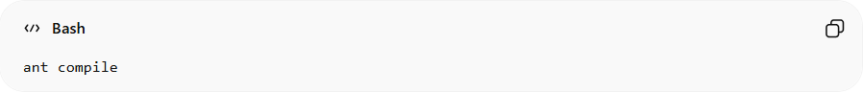
ant compile
📦 Build JAR:
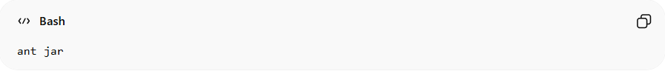
ant jar

📁 How Ant Works
# Source: AI Source: Provided by: [Data Path: Persons Table -> ID Column: 1, Name_En Column: Motasem Essam] -> From: [ChatGPT] on [1/26/2026]
Ant reads the build.xml file and:
- Executes defined targets
- Follows dependencies between targets
- Runs tasks in order
👉 Everything is defined in XML structure

⚠️ Limitations of Ant
# Source: AI Source: Provided by: [Data Path: Persons Table -> ID Column: 1, Name_En Column: Motasem Essam] -> From: [ChatGPT] on [1/26/2026]
• XML can become verbose and repetitive
• No built-in dependency management
• Harder to maintain in large projects
• Replaced often by tools like Maven / Gradle

🧠 Ant vs Make
# Source: AI Source: Provided by: [Data Path: Persons Table -> ID Column: 1, Name_En Column: Motasem Essam] -> From: [ChatGPT] on [1/26/2026]
Feature Make Ant
Language Scripts XML
Platform Mainly Linux Cross-platform
Use Case C/C++ Java
Dependency Mgmt Basic Limited
Ease of Use Medium Structured but verbose

🧠 Quick Summary
# Source: AI Source: Provided by: [Data Path: Persons Table -> ID Column: 1, Name_En Column: Motasem Essam] -> From: [ChatGPT] on [1/26/2026]
Ant = XML-based build tool for Java
✔ Uses build.xml
✔ Automates compile & packaging
✔ Cross-platform

